TEI480T+How to configurate Multi-WAN policy
Product line: Router Question category: Function configurations

Example: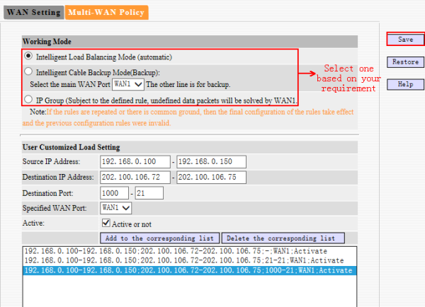
For the User customized Load Settings:
The example shows that IP address 192.168.0.100-192.168.0.150 will send or receive message from port 1000 to 21 on 202.100.106.72-202.100.106.75 through the WAN 1. not WAN2.

Notice:
User Customized Load Setting is prior than Working Mode. If there is a collision between the two rules, the User Customized Load Setting will take effect.

